1.Introduction
This report pulls data from the World Open Data platform, investigating poverty and inflation rates in South Africa from 1993 -2022. The objective of this research and analysis is to identify relationships between the poverty headcount ratio(inflation)and inflation rates as well as point out some historical insights. The analysis yielded four main findings:
Findings of this report are as follows:
- Poverty Rate Went Down: Starting at a 75.4% poverty level in 1993 dipped down to 59.6% in 2022, which is a reduction of 15.8% between 1993 and 2022.
- Inflation Rates Went Crazy: Over the same period, the inflation rate varied greatly, peaking at its highest record inflation rate of 11.02% in 2008.
- Poor Correlation Between Two Indicators: r=0.03. These two indicators had little to no relationship and trended mostly independently of each other.
- Limited Data Points: We were only able to collect data from 7 years (1993- 2022). This is because poverty levels are only collected every few years through the household survey method. This made it hard to get years that had both poverty level observations and inflation rate observations.
This report follows the general data analysis workflow of preparing data, analysing data (Numerically and graphically), as well as loading it into a database. Graphical representation of the data helps one to visualize and draw insights on the changing economic well-being of South Africa.

2. Methodology
Approach to Analysis: The steps to our analysis were broken down into the following segments:
I) Acquiring Data
Two data sources about South Africa were acquired from the World Bank Open Data Portal tal (https://data360.worldbank.org/en/search?country=ZAF):
- Poverty Dataset: "Poverty headcount ratio at $6.85 a day (2017 PPP) (% of population)."
- Inflation Dataset: "Inflation, average consumer prices, Percent change."

(II) Data Preparation and Cleaning
The originally downloaded datasets were prepared using Python (Pandas, NumPy). Steps include:
- Loading: Read files into Pandas DataFrames
- Filtering: We filtered records to show only South Africa (ZAF). For inflation, we only kept historical values (OBS_STATUS = "Normal value") and dropped forecasts.
- Reshaping: Original datasets were wide, with years as columns. These were transformed to long tidy data frames with "Year" and "Value" columns using pd.melt()
- Type Conversion: "Year" and value columns were cast to numeric.
- Handling Null Values: This was an acceptable step because poverty measurements aren't taken every year. (56 of 63 observations were dropped). Imputation could introduce artificial trends.
- Joining - Poverty and Inflation datasets were merged on the "Year" column. An inner join resulted in a final dataset of 7 years for which both indicators are available.

(III) Data Analysis
- Numerical: Using NumPy, we calculated descriptive statistics about our data, including mean, median, standard deviation, and min and max values.
- Correlation: We calculated the correlation coefficient between our two arrays: Poverty and Inflation.
(IV) Data Visualization
- Charts were produced using Matplotlib and Seaborn to visualize the data. Visualizations include:
- Bar & Line Charts: Visualize trends over time.
- Scatter Plot: Shows correlation between the two variables.
- Box Plots & Histograms: Show distribution of the data.
- Heatmap: Visualize year-on-year changes.
(V) Database Integration
- An SQLite database was created, and the merged dataset was loaded.
- Queries were run against the database to show additional data.
3. Data Preparation and Validation: Results

(I) Data Loading and Initial Inspection

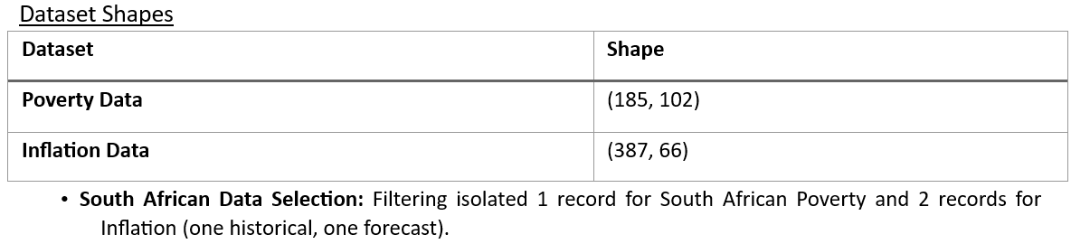 (IV) Data Validation
• Cleaned/reshaped datasets were validated.

Table 3: Validated Datasets
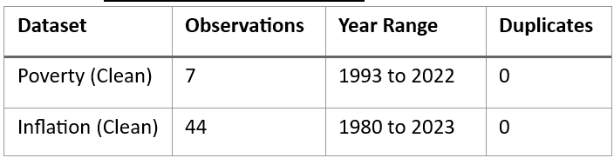

(V) Final Integrated Dataset

Final Integrated Dataset
The poverty and inflation datasets were merged using an inner join on the column "Year" to further explore the relationship between poverty and inflation. The final dataset consists of 7 years of data where both indicators can be analysed.
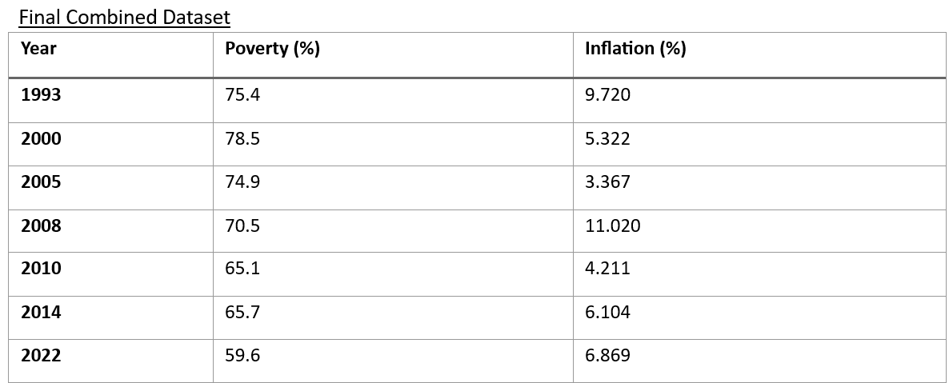
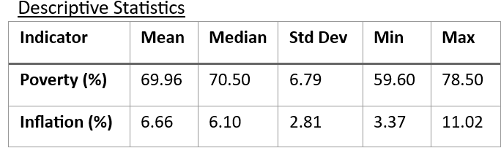
Data Preparation (Key Findings):
- The average poverty rate was around 69.96%, whereas the average inflation rate stood at approximately 6.66%.
- Throughout the period under review, the poverty rate dropped by 15.8 percentage points, falling from 75.4% in 1993 to 59.6% in 2022.
- The inflation rate also decreased by 2.85 percentage points, from 9.72% in 1993 to 6.87% in 2022.

4.Numerical Analysis

(I)Data Arrays
The data from the combined dataset was removed into three different arrays for analysis:
- Years - 1993, 2000, 2005, 2008, 2010, 2014, 2022
- Inflation - 9.72, 5.32, 3.37, 11.02, 4.21, 6.10, 6.87
- Poverty - 75.4, 78.5, 74.9, 70.5, 65.1, 65.7, 59.6

(II) Summary Statistics with NumPy
Detailed statistics were calculated direct from the NumPy arrays to deliver a rigorous numerical summary of the data.

NumPy Descriptive Statistics & Variability

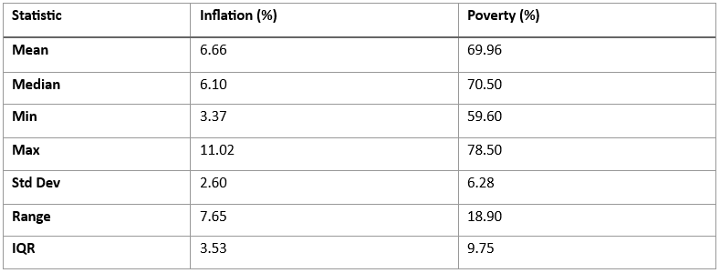 (III)Identifying Extreme Values
- Inflation: Greatest rate was 11.02% in 2008 (Worldwide financial crisis) & the least was 3.37% in 2005.
- Poverty: Greatest rate was 78.5% in 2000 & the least was 59.6% in 2022.

(IV)Correlation Analysis
• Correlation (r): 0.03 — These indicates a very feeble positive relationship, and this indicating no strong linear relationship between inflation and poverty.

Year-on-Year Changes (Percentage Points)
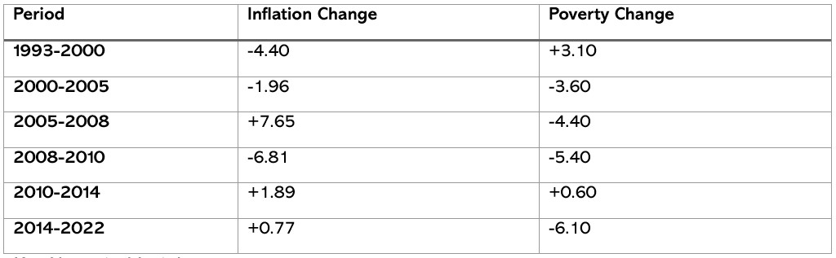

Numerical Insights
- Period of 2008 is prominent as an extreme point, with inflation achieving its highest value is 11.02%, while poverty is 70.5% remained close to its average.
- Period of 2022 marks the least poverty rate identified is 59.6%, indicating progress in reduction of economic suffering, although inflation increased.
- Regarding the near-zero correlation between inflation and poverty (r=0.03) is the most essential numerical insight, makes it difficult to assume that these two economic indicators are strongly linked.
- Moving towards to the standard deviation for poverty which is 6.28% is more than double that of inflation that is 2.60%, these indicate higher instability in poverty rates over the chosen period.

5.Visualization
This part displays the types of key visualizations developed during this analysis. Each chart is created to convey a specific insight about the connection and trends in South Africa's poverty & inflation data.

(I)Inflation Bar Chart
This Bar Chart visualization presents the inflation rate for each of the selected years.
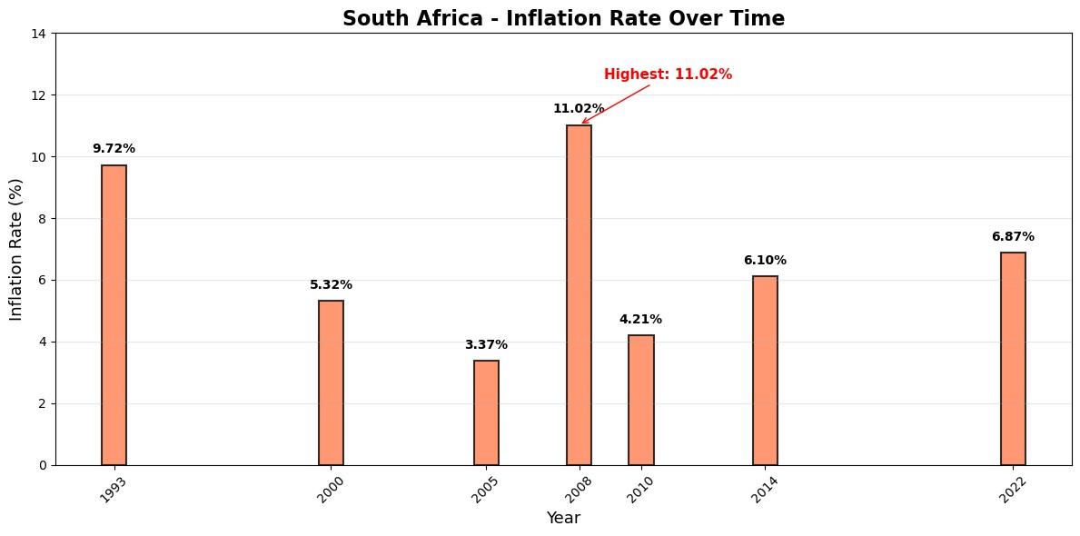
- The bar chart above practically highlights the inflation highest point in 2008 and the least in 2005.
- It gives a clear, consecutive view of inflation over the period.
(I)Inflation vs. Poverty Dual-Axis Line Chart:
The dual-axis line chart is an exceptional tool for comparing the trends of inflation and poverty on the equal timescale.
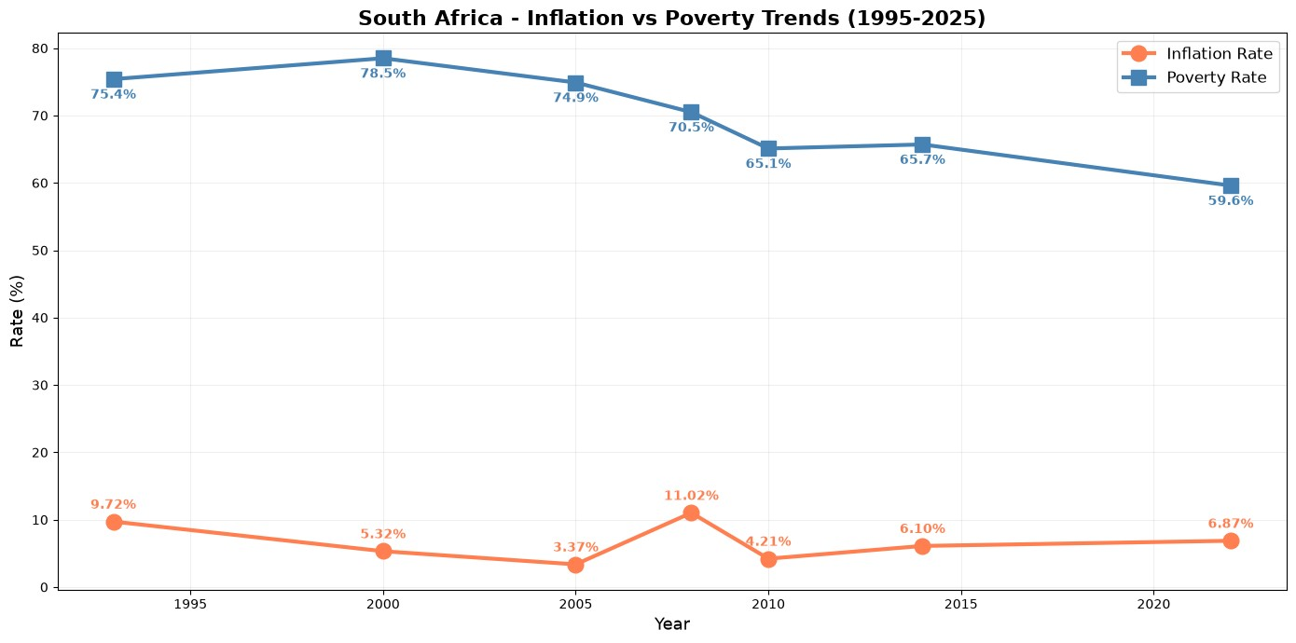
- The above information provided shows a slight negative relationship, where poverty usually declines while inflation varies over time.
(III)Scatter Plot of Inflation vs. Poverty:
The scatter plot effectively presents a weak correlation (r = 0.03) which is calculated in the numerical analysis.
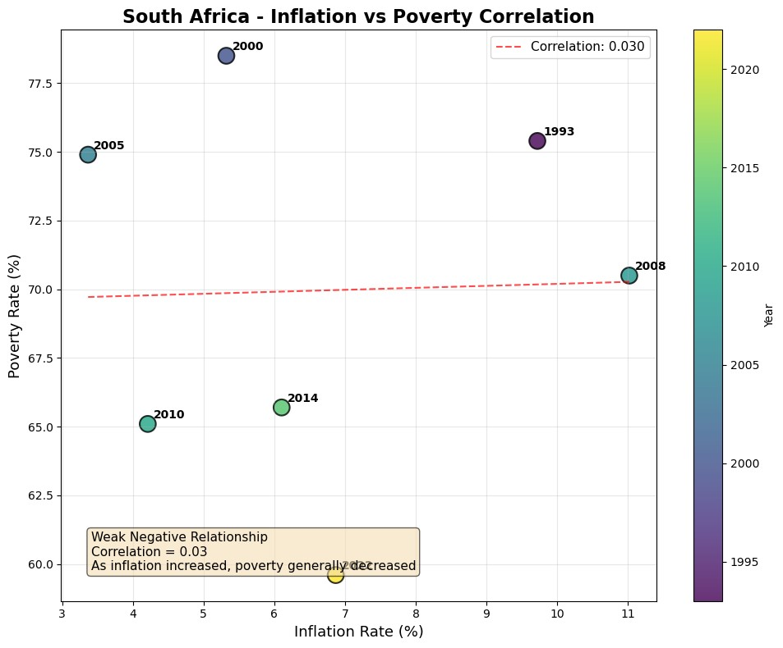
- Data points are broadly scattered, proving no clear linear pattern.
- The reference Lines presents the mean inflation and mean poverty.
- Notable points above year of 2008 point shows greater inflation rate but moderate poverty. The year of 2022 point shows least poverty rate but moderate inflation.
(IV) Box Plots for Statistical Distribution:
The box plots below provides an insights into the central tendency, spread, and distribution shape of the data.

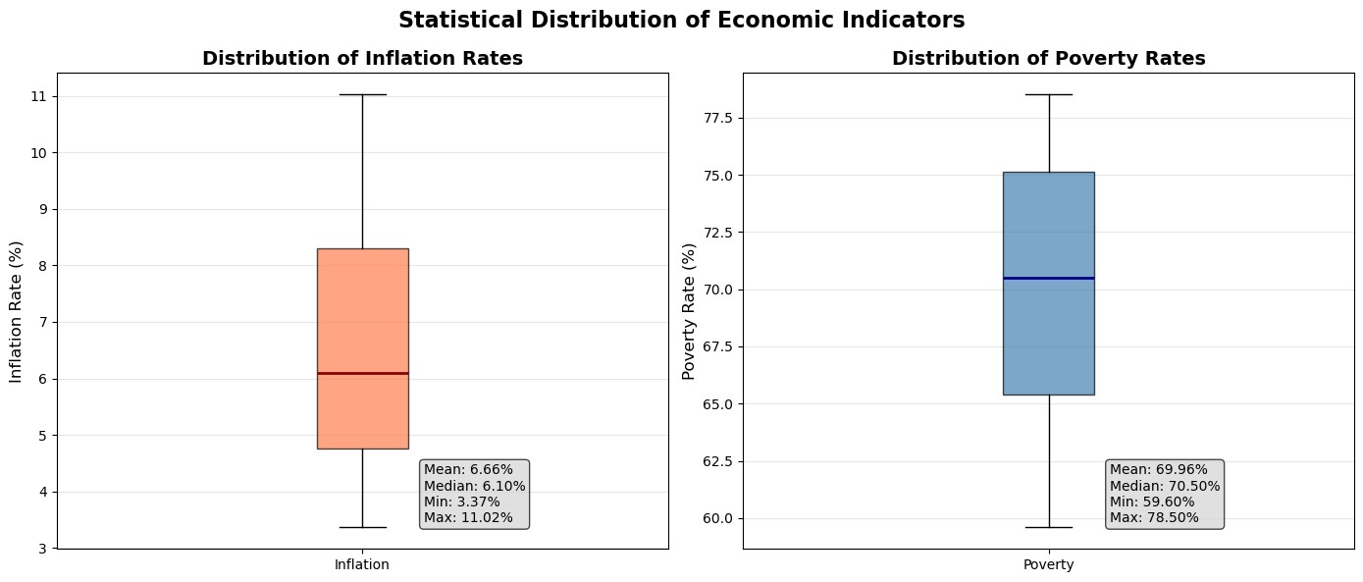
- Inflation: Displays a mean of 6.66%, median of 6.10%, range between 3.37% to 11.02% and an outlier at 11.02% (2008).
- Poverty: Displays a mean of 69.96%, median of 70.50%, range 59.60% to 78.50% and a more symmetrical distribution with no extreme outliers.

(V)Histograms
The histograms support in visualizing the frequency of distinct value ranges for each indicator.
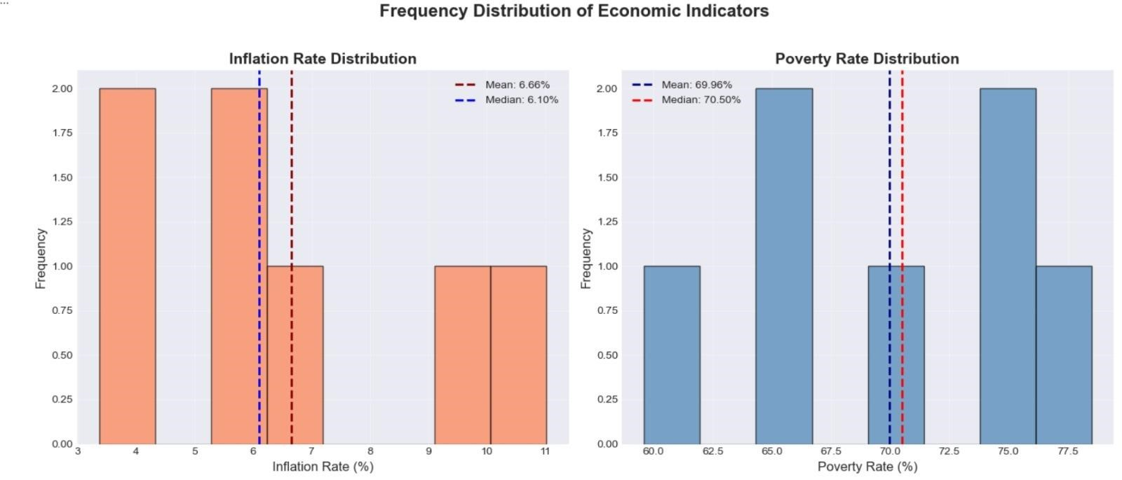
- Inflation Histogram: Concentrated between range of 3-7% and One data point above 10% in year of 2008
- Poverty Histogram: Relatively consistent distribution across the range and minor concentration in the 65-70% range.

6. Database Integration
This section fully details the development and use of an SQLite database to preserve and manage the economic data, with support of database activities involving the actual code, query results, and database evidence supporting pictures.

(I) Database Schema Design
A relational database was developed and well applied using SQLite to store the analysed South African economic data. The database contains two tables: inflation_data & poverty_data, which are connected through the year field.
Relational Database Schema Diagram:
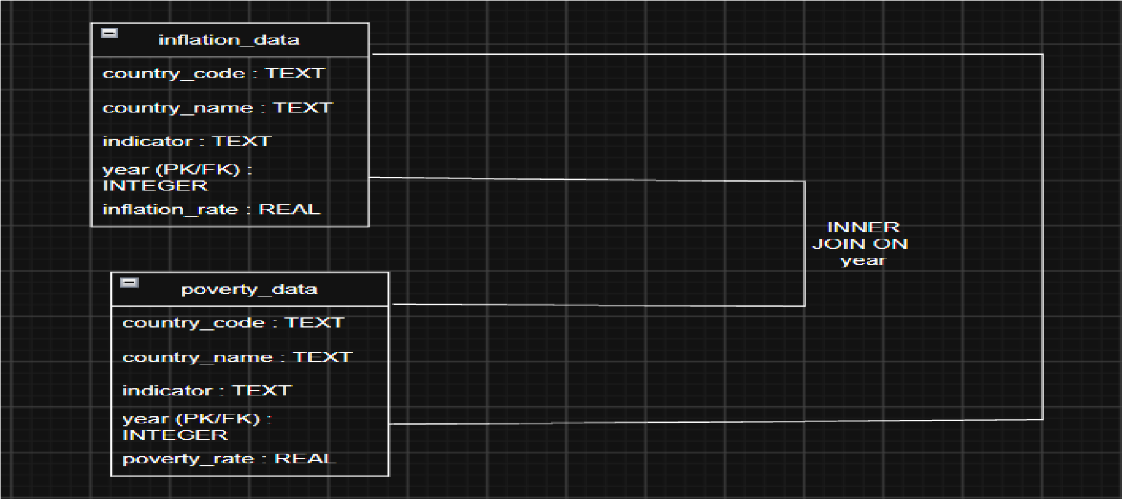
• This Diagram presents the structure of both tables involving country_code, country_name, indicator, year, and rate fields

(I) Database Creation and Data Insertion
- The SQLite database named zaf_economic_data.db was developed. All the raw datasets were fully cleaned, reshaped from broad to build a long format using pd.melt(), and also inserted into their expected tables using df.to_sql().

This is the evidence that illustrates a successful database consumption and schema implementation. The validation query it 100% confirms:
- 50 records of inflation_data from 1980-2029 & 7 records of poverty_data (1993, 2000, 2005, 2008, 2010, 2014, 2022)
“This verifies that the data cleaning, reshaping, and insertion methods completed precisely.”

(III) The Relational JOIN & Aggregation Queries
To fully analyse the relationship between inflation and poverty, an “SQL INNER JOIN” was used to match both indicators by year.
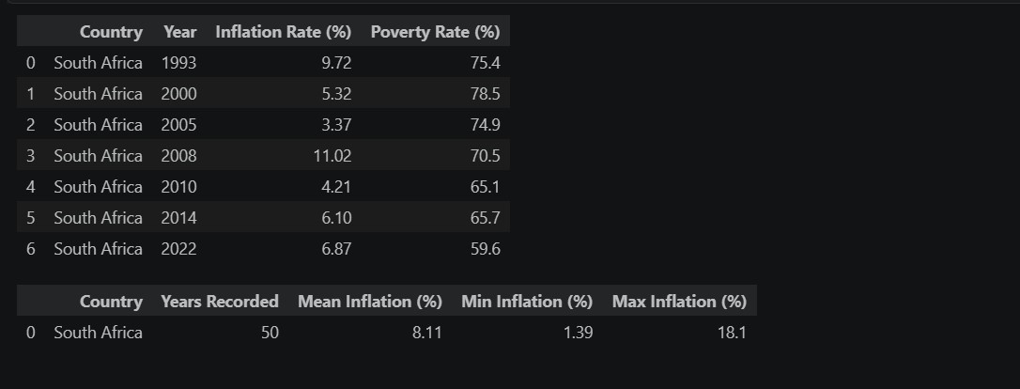

Query 1:

INNER JOIN The query matched inflation and poverty data for overlapping years, returning 7 rows (1993, 2000, 2005, 2008, 2010, 2014, 2022). This forms the foundation for the correlation analysis presented earlier in the report, showing that inflation and poverty data are available for exactly 7 years.

Query 2:

Statistical Aggregations Looking at aggregation is query calculated summary statistics for SA inflation across all these 50 years of data therefore the Mean Inflation = 8.11%, Minimum Inflation =1.39% (2004), Maximum Inflation = 18.1% (1986) These statistics gives an insightfor understanding SA's long-term inflation trends.

(IV)The Safe UPDATE and DELETE Operations

Data integrity & safe transaction process were demonstrated using targeted WHERE clauses to perform UPDATE and DELETE activities.
Safe UPDATE:
In the year of 2020 inflation record was changed from its original value to 5.25% as a test process. The strict WHERE clause (WHERE country_code = 'ZAF' AND year = 2020) guarantees that only the aimed record were affected, avoiding accidental data corruption.
Safe DELETE:
Projected or forecast data past 2030 was eliminated from the database. The verification query successfully confirmed:
• Min Year: 1980, Max Year (Post-Delete): 2029 & Remaining Records: 50
This shows that the DELETE operation was completed safely with an exact WHERE condition, maintaining data integrity.

7.Python/Excel Analysis

(I)Data Transformation
The dataset was changed by simple renaming all columns for clarity, adding year-on-year change columns for inflation and poverty, filtering for high-poverty years which are >70%, sorting to define high-inflation periods, and grouping by decade to fully analyse long-term trends.

(II)Conditional Formatting Color-Coded Table
This table uses color coding which is more similar to Excel's conditional formatting to highlight inflation severity levels.
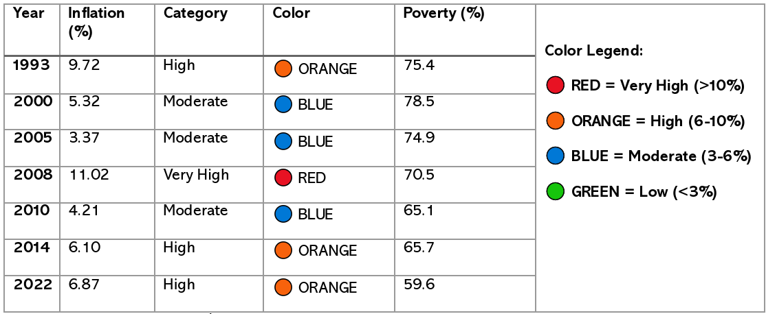
The Greatest inflation is 11.02% occurred in 2008 during the world-wide financial crisis, while the least which is 3.37% was in 2005 during a period of economic steadiness. The Greatest poverty rate is 78.5% was recorded in year of 2000, and the lowest is 59.6% in the year of 2022, displaying a record low over the 29-year period.

(III)Aggregated Summary (Pivot Table Equivalent)
Decade-wise analysis displays that the 1990s had high inflation of 9.72% and higher poverty of 75.4%. The 2000s shows a moderate inflation of 6.57% with poverty remaining higher at 74.6%. The 2010s had low inflation of 5.16% and moderate poverty of 65.4%. The 2020s documented moderate inflation of 6.87% with poverty dropping to a record low of 59.6%.

(IV)Categorization of Economic Indicators
Inflation was classified as high which is >7%, moderate 4-7%, or low <4%. Poverty was classified as high >70%, moderate 65-70%, or low <65%. In 1993, both of these indicators were high. In 2000 had moderate inflation but greater poverty. In 2005, inflation<poverty. In 2008 displays high inflation and high poverty. The 2010s documented moderate levels for both of these indicators, while 2022 giving moderate inflation with poverty at a record low as 59.6%.
8.Conclusion
In conclusion, the research shows that the poverty rate in South Africa declined between 1993 and 2022, while the inflation rate changed over time. Results indicate that there's a weak relationship between the two variables, with a correlation of r=0.03. This proves that inflation alone did not have a very strong connection with changes in poverty.
The analysis also indicates the importance of using data analysis to better understand economic patterns and changes over time. However, the results were limited due to the small number of years in which both poverty and inflation data were present.

